Edunet Virutal Internship
Assessment No. 1
#What is deep learning?
Deep learning is a technology that helps computers learn and understand things like humans do. It works by copying how our brain’s neural networks function. With deep learning, computers can look at large amounts of messy data (like pictures, videos, or text) and figure out patterns on their own. This helps them make smart decisions without being directly told what to do.
#What is Neural Network?
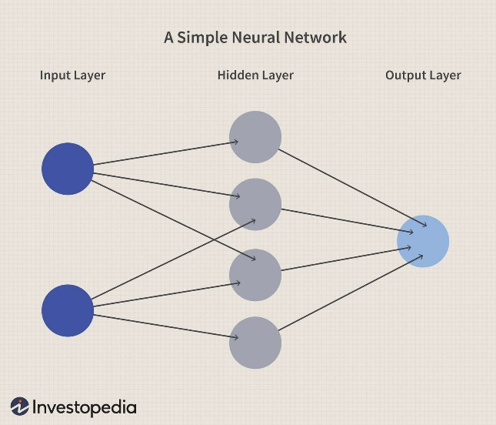
A neural network is like a web of tiny units called neurons. These neurons are arranged in layers and are all connected to each other. They work together to understand the input data (like an image, sentence, or numbers).

🔁 How It Works:
- The input layer takes in the data.
- The data then moves through one or more hidden layers.
In each hidden layer:
  - Neurons perform special calculations (called nonlinear transformations) to understand patterns.
- Finally, the output layer gives the result — like a prediction or classification.
Each layer helps the model learn something deeper and more detailed about the data. That’s why it’s called “deep” learning!
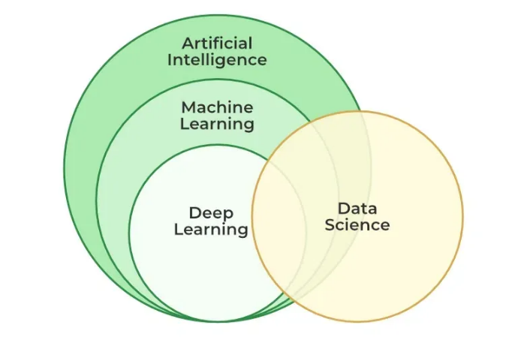

Types of Neural Networks
- Feedforward Neural Networks (FNNs)
  - Data moves only one way — from input to output.
  - Used for simple tasks like classifying images or data.
- Convolutional Neural Networks (CNNs)
  - Great for working with images.
  - They can find patterns like edges, shapes, and textures.
  - Used in tasks like face detection and object recognition.
- Recurrent Neural Networks (RNNs)
  - Designed to handle sequential data (like time series, text, or speech).
  - They remember past information using loops.
  - Versions like LSTMs and GRUs solve memory issues.
- Generative Adversarial Networks (GANs)
  - Made of two parts: a Generator (creates fake data) and a Discriminator (tries to tell real from fake).
  - Used for things like creating new images or improving photo quality.
- Autoencoders
  - Learn to compress data and then rebuild it.
  - Helpful for removing noise, detecting unusual patterns, or reducing data size.
- Transformer Networks
  - Amazing for Natural Language Processing (NLP).
  - Use a method called self-attention to understand word meanings in context.
  - Behind famous models like GPT and BERT — used for translation, summarization, and more.

Neural Network Type | Popular Technologies / Models | Main Applications
Feedforward Neural Network (FNN) | Scikit-learn models, MLPClassifier | Basic classification, regression, spam detection, fraud detection
Convolutional Neural Network (CNN) | YOLO, ResNet, VGG, AlexNet, EfficientNet | Image classification, object detection, face recognition, medical imaging
Recurrent Neural Network (RNN) | Vanilla RNN, Deep RNN | Sequence modeling, time-series forecasting, basic NLP tasks
LSTM / GRU (Advanced RNNs) | TensorFlow LSTM, Keras GRU layers | Chatbots, speech recognition, language translation, music/text generation
Generative Adversarial Network (GAN) | StyleGAN, CycleGAN, DCGAN | Image synthesis, deepfakes, art generation, data augmentation
Autoencoder | Variational Autoencoder (VAE), Denoising Autoencoder | Anomaly detection, noise reduction, feature compression, recommendation systems
Transformer Network | BERT, GPT, T5, RoBERTa, XLNet | Text generation, translation, summarization, Q&A systems, sentiment analysis

